

Practices for Secure Software Report

Table of Contents
Document Revision History 3
Client 3
Developer 3
1. Algorithm Cipher 3
2. Certificate Generation 4
3. Deploy Cipher 4
4. Secure Communications 5
5. Secondary Testing 6
6. Functional Testing 7
7. Summary 7
8. Industry Standard Best Practices 8

Document Revision History

Version | Date | Author | Comments
1.0 | 8/20/2026 | Ambren Cavazos

Client



Developer
Ambren Cavazos

Algorithm Cipher
For Artemis Financial’s application, I used SHA-256 as the cryptographic hash algorithm for checksum verification. SHA-256 is part of the SHA-2 family and produces a fixed 256-bit hash value from an input string or file. This is useful because even a small change in the original data should create a completely different checksum. That makes SHA-256 appropriate for verifying that transferred data has not been changed.
SHA-256 is not encryption because it is a one-way hash function. Encryption is meant to protect confidentiality and can be reversed with the correct key. A hash function is used for integrity verification and cannot realistically be reversed back into the original message. In this project, SHA-256 was used to create a checksum from a unique data string so the application could demonstrate data verification.
The checksum process does not require symmetric or asymmetric keys. Symmetric encryption uses the same key to encrypt and decrypt data, while asymmetric encryption uses a public and private key pair. In this project, HTTPS and the self-signed certificate help secure communication, while SHA-256 provides the checksum verification. Older hash algorithms such as MD5 and SHA-1 are no longer considered strong choices for secure applications, so SHA-256 is a better option for Artemis Financial’s need to protect client data and financial information.

Certificate Generation
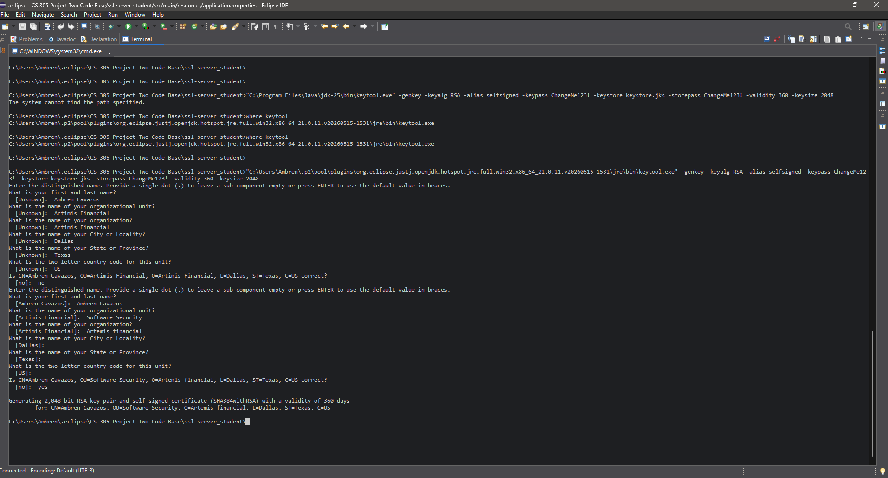

Deploy Cipher
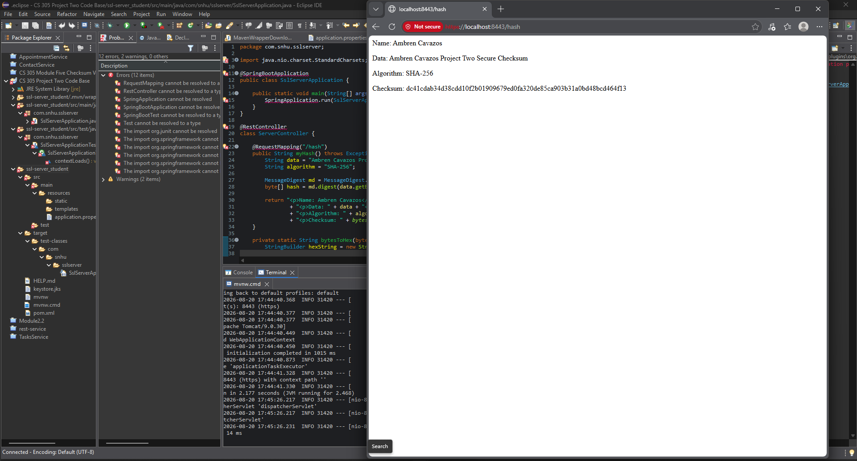

Secure Communications
The application was configured to use HTTPS on port 8443 using a self-signed certificate generated with Java Keytool. The browser shows the application running at https://localhost:8443/hash. Because this certificate was self-signed for local testing, the browser may label the connection as not secure. However, the HTTPS URL verifies that the application was refactored from HTTP to HTTPS and that secure communication is enabled for the local server. 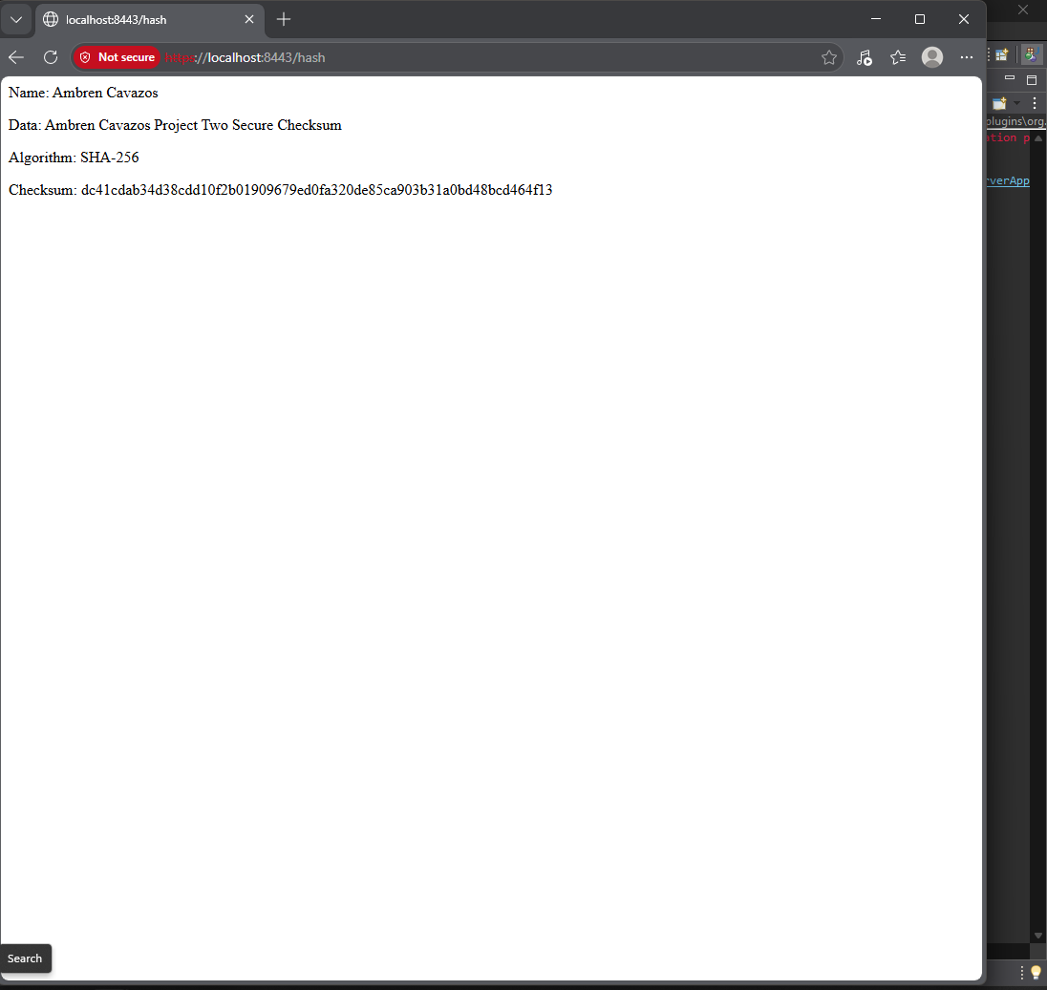

Secondary Testing
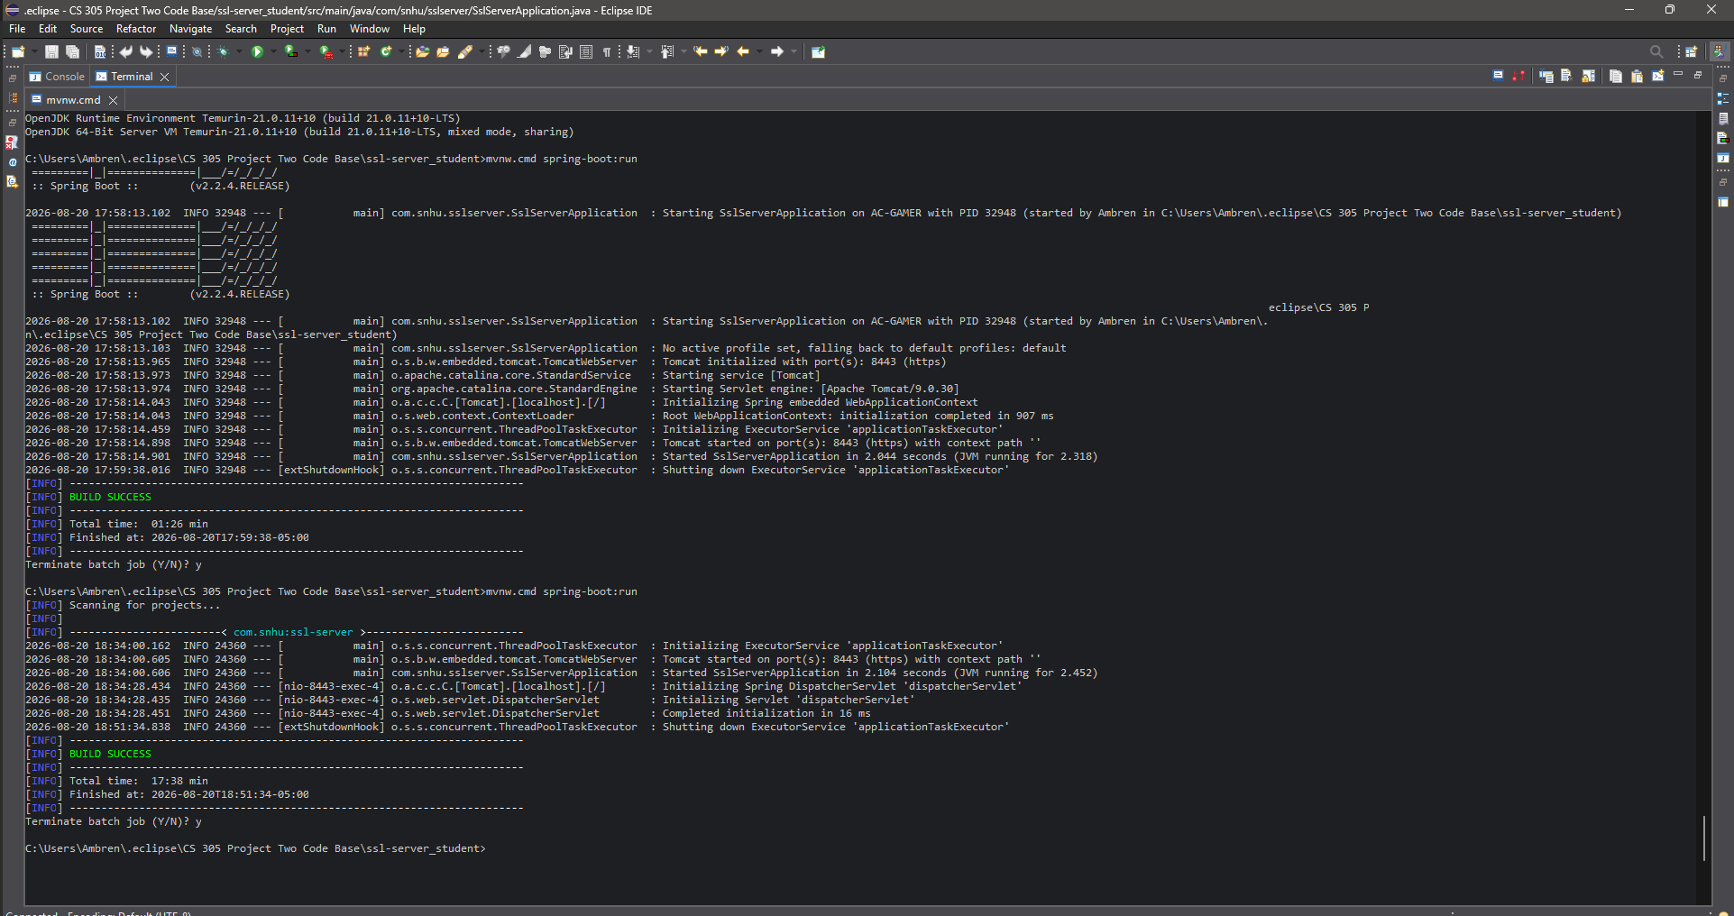
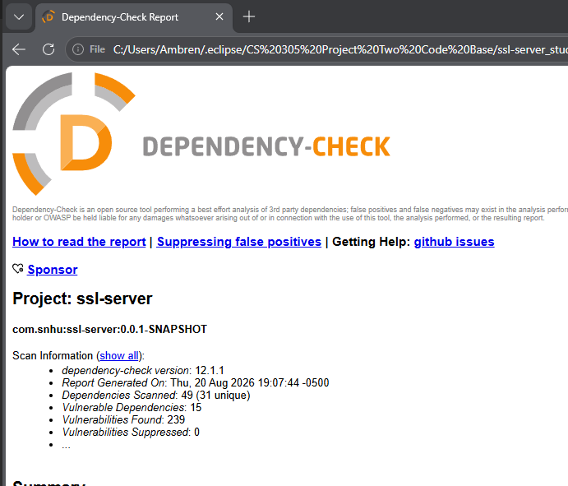

Functional Testing

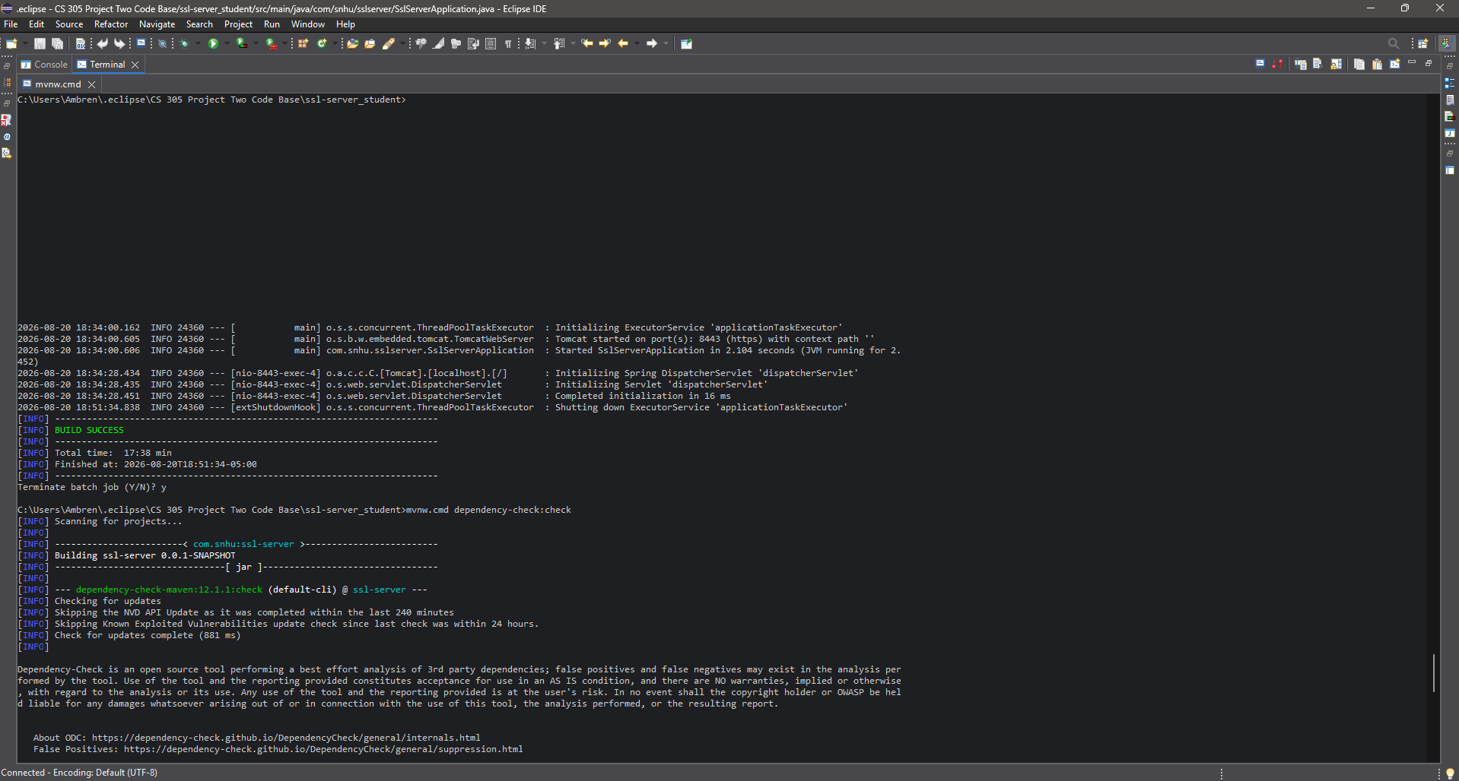
I performed functional testing by running the refactored application and checking whether the /hash endpoint worked correctly. I verified that the application started successfully, that the HTTPS port was active, and that the browser could access the checksum page. I also reviewed the code for syntax errors, logic errors, and security concerns.
During the manual code review, I checked that the SHA-256 algorithm was called correctly, that the unique data string was passed into the hash function, and that the byte output was converted into a readable hexadecimal checksum. I also reviewed the HTTPS configuration to make sure the keystore settings matched the certificate information. The application executed without errors, which supports that the refactored code worked as intended.

Summary

The Artemis Financial application was refactored to add secure communication and checksum verification. I added a /hash endpoint that uses SHA-256 to create a checksum from a unique data string. I also configured the application to use HTTPS on port 8443 with a self-signed certificate created through Java Keytool. These changes added security layers to the application by supporting data integrity and secure communication.
The areas of security addressed in the refactoring included cryptography, secure communication, dependency testing, and manual code review. The checksum supports integrity because it helps verify that data has not changed. HTTPS supports confidentiality and secure communication while data is being transferred. Dependency-Check supports secure software testing by identifying known vulnerabilities in third-party components.
My process was to first identify the security requirements, then implement the checksum functionality, then configure HTTPS, then test the refactored application. After the application ran successfully, I completed secondary testing with Dependency-Check and manually reviewed the code for possible syntactical, logical, and security issues. This process follows secure software testing protocols because it combines implementation, verification, static testing, and manual review.

Industry Standard Best Practices

I applied industry standard best practices by using a current hash algorithm, enabling HTTPS, generating a certificate, and running dependency testing. SHA-256 was used instead of weaker older algorithms because it provides a stronger 256-bit digest. HTTPS was used instead of HTTP because data transferred over HTTP is not protected the same way. The certificate and keystore configuration helped secure the application’s communication channel.
I also used static testing with OWASP Dependency-Check to review third-party dependencies. This is important because vulnerabilities can exist in libraries even when the developer’s own code works correctly. By reviewing dependency-check results, developers can identify libraries that may need updates or further review.
These best practices help Artemis Financial protect client data and financial information. Secure coding protects the company’s reputation, reduces the chance of data exposure, and helps maintain customer trust. Applying security throughout development is also more effective than waiting until after deployment because it allows issues to be found and corrected earlier.

